240 A10 NO OUTSIDE DISCUSSION; Consulted Wikipedia

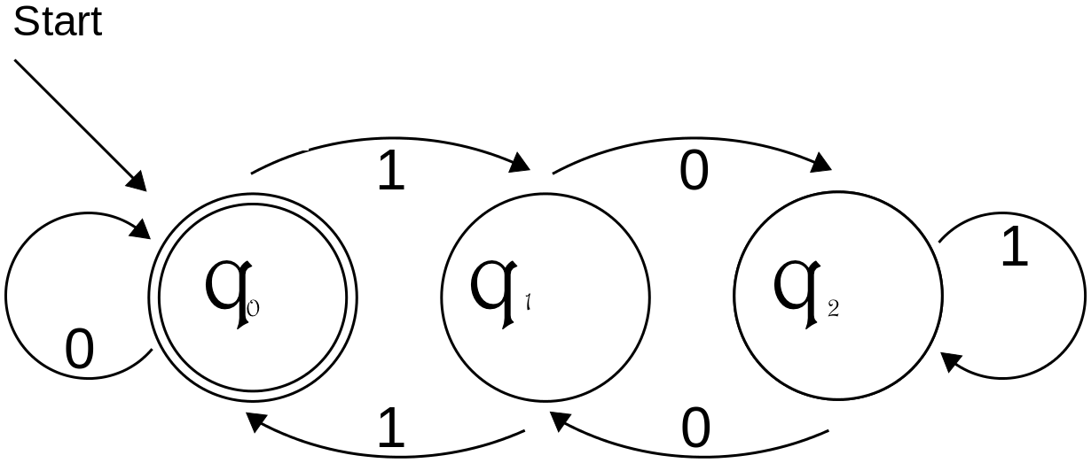The deterministic finite automaton A = (Q, Σ, δ, s, F ),

is the graph below:

Lemma2: $∀ a, b ∈N, \left(3\left|a AND 3\right|b\right)IMPLIES3|\left(a+b\right)$

$(directly from the property of exact division)$

Lemma3: $x is a binary representation of natural number, so assume x has m digits, and x=a\left[1\right]a\left[2\right]…a\left[m\right]. Assume x is formed of i 1s and j 0s \left( i+j=m\right).$

Let x’ = $a\left[1\right]a\left[2\right]…a\left[m\right]a\left[m+1\right],$ where a[m+1] is a new number that can be either 0 or 1.

If a[m+1] = 0, then x’ = 2 $× x$.( from the property of binary system) and x’ $≡2x\left(mod 3\right)$ ( from the property of modulo)

Else if a[m+1] = 1, then x’ = 2 $× x+1$. ( from the property of binary system). and x’ $≡2x+1\left(mod 3\right)$ ( from the property of modulo)

Lemma4:

For deterministic finite automaton A, q0 accepts binary representation of either empty string or a natural number r. q1 accepts binary representation of a natural number r. q2 accepts binary representation of a natural number r $≡2 \left(mod 3\right).$

Prove by induction:

Firsty, if input is an empty string, it end with q0 , so q0 accepts binary representation of either empty string or a natural number r $≡0 (mod 3)$ is true when input is an empty string.

Let P0 =” For deterministic finite automaton A, q0 accepts binary representation of a natural number r.” P1 =” For deterministic finite automaton A, q1 accepts binary representation of a natural number r.” P2 =” For deterministic finite automaton A, q2 accepts binary representation of a natural number r $≡2 (mod 3)$.”

Base cases:

1.If x =0, the binary representation x =a[0]=0.

2. δ(q0, 0) = q0

3. P0 is true.

4. If x =1, the binary representation x =a[0]=1.

5. δ(q0, 1) = q1

6. P1 is true.

7. If x =2, the binary representation x = a[0] a[1]=10.

8. δ\*(q0, x) = δ(δ(q0, 1),0)= δ(q1,0)= q2

9. P2 is true.

10. If x =3, the binary representation x = a[0] a[1]=11.

11. δ\*(q0, x) = δ(δ(q0, 1),1)= δ(q1,1)= q0

12. P0 is true.

Constructor cases:

13. Assume for an arbitrary natural number x, The binary representation of x is: x = $a\left[1\right]a\left[2\right]…a\left[m\right]$. Let y = and P0, P1 and P2 is true for y, which means:

δ\*(q0, y) =

14. δ\*(q0, x)= δ(δ\*(q0, y),a[m])

15. if a[m]=0, x = 2y and x (from lemma 3)

16. if δ\*(q0, y)= q0, then (from 13)

17.x (from 15, 16)

18. δ(q0,0) = q0

19.P0 is true for this case. (from 17, 18)

20. if δ\*(q0, y)= q1, then (from 13)

21.x (from 15, 20)

22. δ(q1,0) = q2

23.P2 is true for this case. (from 21, 22)

24. if δ\*(q0, y)= q2, then (from 13)

25.x (from 15, 24)

26. δ(q2,0) = q1

27.P1 is true for this case. (from 25, 26)

28. else if a[m]=1, x = 2y +1and x (from lemma 3)

29. if δ\*(q0, y)= q0, then (from 13)

30.x

31. δ(q0,1) = q1

32.P1 is true for this case.

33. if δ\*(q0, y)= q1, then

34.x

35. δ(q1,1) = q0

36.P0 is true for this case.

37. if δ\*(q0, y)= q2, then

38.x

39. δ(q2,1) = q2

40.P2 is true for this case.

41. So, P0, P1 and P2 is true for y IMPLIES P0, P1 and P2 is true for x (from 13 and (19, 23, 27, 32, 36, 40))

42. By induction, P0, P1 and P2 is true for all natural numbers.

Question 1:

A is in the picture above, and since P0 , P1and P2is correct from lemma4, A is correct.

Question 2:

Proof:

Consider a deterministic finite automaton B = (Q, Σ, δ, s, F) such that $L\left(B\right)=L$ and |Q|<3. Then, there exist at least two possibilities that lead to the same state. Assume the two states are q0 and q1, q0 is the initial state and one of q0 ,q1 is final state (if they are all finial states then $L\left(B\right) ≠L$ because for example, 101 is not in L.).

Case 1: δ ( q0 , 0) = q1, then q1 is final state because 0 is in L. Then,

δ ( q0 , 1) = q0 because 1 is not in L. So, δ \*( q0 , 10) = q1 , but 10 is not in L, so this form of DFA B is impossible to make $L\left(B\right)=L$.

Case 2: δ ( q0 , 0) = q0, then q0 is final state because 0 is in L. Then,

δ ( q0 , 1) = q1 because 1 is not in L. δ \*( q0 , 10) = q1 because 10 is not in L, so we have δ ( q1 , 0) = q1. What’s more, δ \*( q0 , 11) = q0 because 11 is in L, so we have δ ( q1 , 1) = q0. Now, we have δ \*( q0 , 101) = q0 from above analysis, but 101 is not in L, so this form of DFA B is impossible to make $L\left(B\right)=L$.

Both case 1 and case 2 are impossible, which are all the possibilities exist for such B, so such B does not exist.

Question 3:

Answer: R = 0+(1((10\*1) +(01\*0))\* 10\*))

Proof, firstly, a number in binary from is either 0 or begin with 1. When the number is 0, then it is divisible by three. So, R here is either 0 or (1((10\*1) +(01\*0) )\* 10\*)). $L\left(R\right)=$ For the deterministic finite automaton A, δ(q0,1)= q1 . So, if and only if

δ \*( q1 , (10\*1) +(01\*0) )\* 10\*) ) = q0 and is all possible way from q1 to q0 . (from lemma4 and the from of R). Moreover, δ \*( q1 , (10\*1)) proceeds like q1q0q1, δ \*( q1 , (01\*0)) proceeds like q1q2q1, δ \*( q1 , (10\*)) proceeds like q1q0, and they are all possible way from

q1 to q0. So, δ \*( q1 , (10\*1) +(01\*0) )\* 10\*) ) is all possible way from q1 to q0 . So,